# Project Design

Template: Advanced web development, A non-profit web application

Title: One-Stop Shop for Volunteering

Author: Gyula Henrik Csendes

## Project overview

I’m building a website where multiple organizations can register and add volunteer opportunities. This way registered volunteers can browse multiple organizations on a single website. The benefit of browsing a single site is advantageous for volunteers as they do not have to register on multiple sites to see opportunities across multiple organizations. This has the benefit for organizations as well, because each organization can bring in their volunteer base and once registered and opted in, organizations can look for volunteers based on location or skill. It will also provide event recommendation and event chat. These options and features answers problems mentioned in reports during the discovery phase.

## Domain and users

The domain of the project is volunteering and how to connect more people to more organizations in a way that simplifies search for both parties and increase engagement through communication and reference. Also to find better candidates for an event based on different search categories. The current implementation is focusing on volunteers in the U.S. as distance search will be based on zip codes within the U.S.

## Justification of design choices

During literature review multiple reports and surveys highlighted an increasing demand for volunteers while the number of volunteers decreased. Organizations reported issues finding new and retaining existing volunteers. They also reported that finding skilled volunteers is also an issue. To them the unified platform can bring new volunteers as people can add their skills and opt-in to appear in searches conducted by the organizations. For the volunteers finding events they would participate becomes easier as they do not need to visit different sites which can increase the number of events they participate. The event recommendation and chat feature also were mentioned in the surveys that can help increase volunteer engagement and increase the sense of belonging.

## Software architecture

1. Frontend: HTML, CSS and possibly JavaScript via Django templates
2. Backend: Django views, models and URLs.
3. Web server: NGINX as a reverse proxy and Gunicorn to connect NGINX with the Django framework
4. Messaging: Redis server will support an event chat feature so event participants can connect real time. Chat history will also be implemented.
5. Database: Oracle Autonomous Database for Transaction Processing. It requires the cx_Oracle package for connection, but I will be relying on Django ORM for data operations

This will be implemented on an Oracle Cloud Infrastructure (OCI). The design can be supported by the always free tier provided by Oracle so there is no cost relation.   
Points 1 to 4 will be implemented on a cloud Oracle Linux 9 server within the given OCI instance. For the database itself I will be using Oracle’s autonomous database within the same OCI instance. It has the advantage of not needing manual installation, only a few clicks and I have a reliable RDBMS that does not need a dedicated database administrator as patches are applied automatically and it also creates backups. Figure 1 shows the planned infrastructure. This infrastructure has the potential to scale up by adding more resources if needed, however at a certain point that might require an upgrade to a paid tier, however Oracle also provides discounts and other benefits for nonprofits.

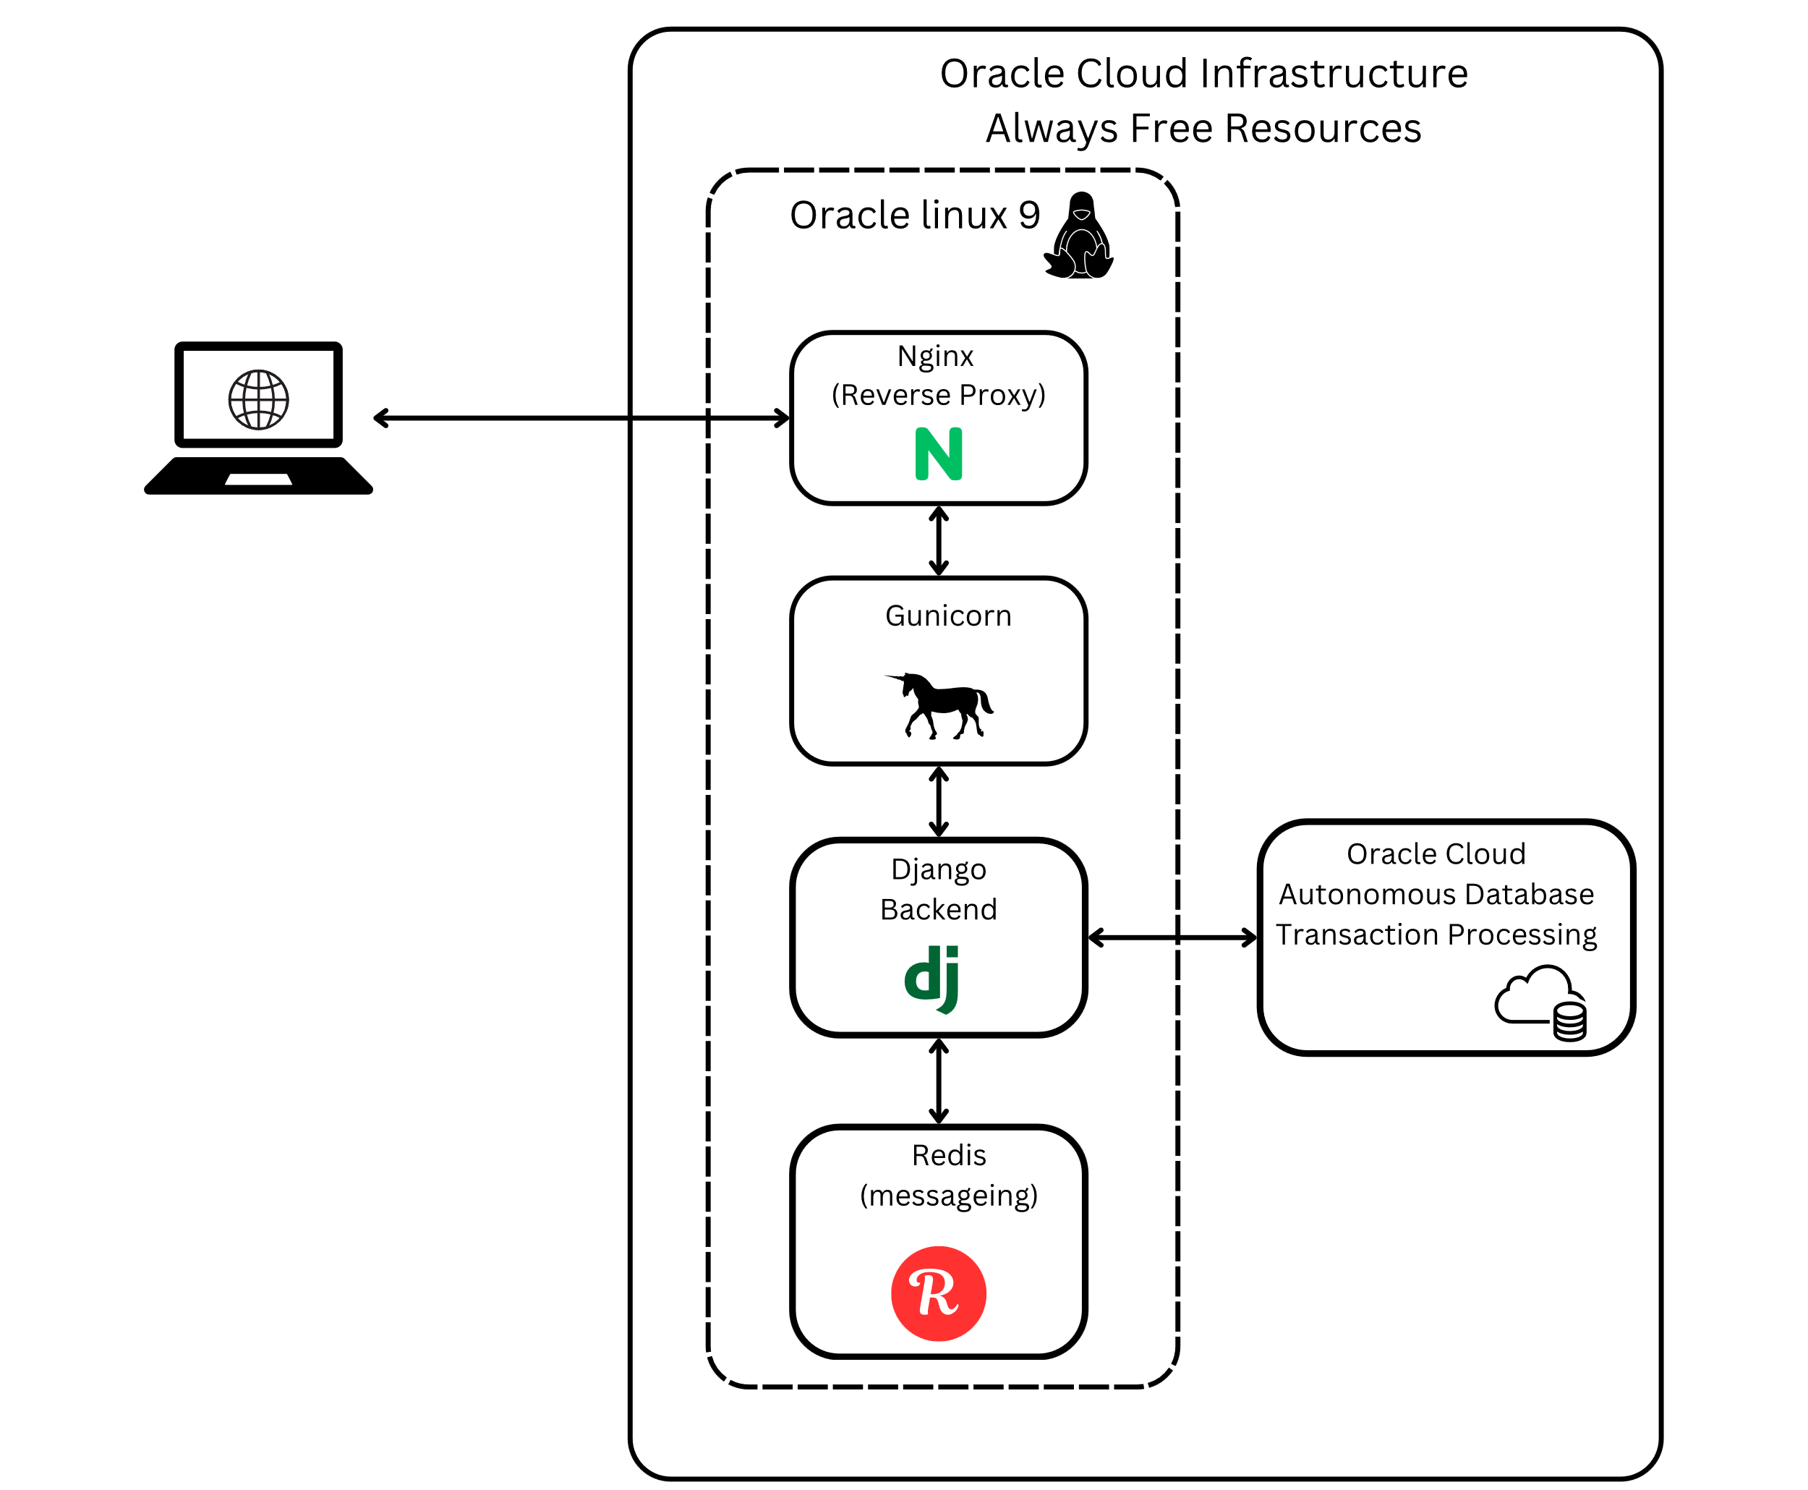

Fig. 1, Implementation on the Oracle Cloud Infrastructure free resources

Code change management is on GitHub. Changes will be committed using GitHub Desktop application.

## Core application features

* User and Organization registration: profile setups. Organization profiles need to be approved by site admin before they can access volunteers or create events
* Event creation: organizations to create events with appropriate details
* Event registration: volunteers to request joining an event
* Event search: volunteers to search events based on different criteria
* Volunteer search: organizations to search for volunteers who opted in to be visible and send events to them
* Volunteer event recommendation: volunteer to send an event recommendation to another volunteer if they are opted in to receive recommendations
* Event chat: volunteers and organizations have a chat room for every event to help build community and simplify communication. Chat is restricted to approved volunteers for the given event

## Implementation plan

Figure 2 shows the planned schedule of the implementation.

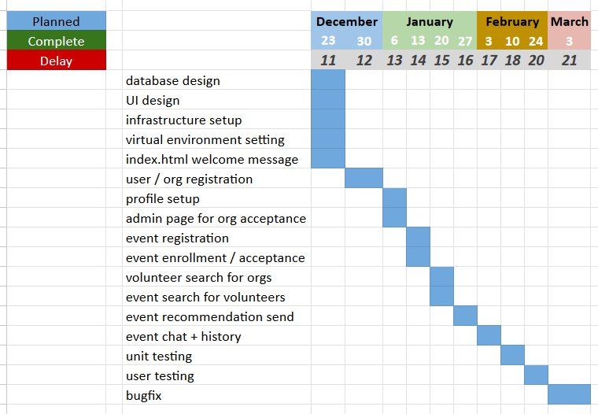

Fig. 2, Scheduled implementation plan

The day represents the planned end day of the given phase. The chart will be updated weekly and will be updated on GitHub, highlighting any delays or if possible, tasks completed ahead of time.

## Testing and evaluation

During development I will be creating unit tests to test functionality. I will also manually test each feature by creating dummy accounts for both organizations and volunteers. Since I’m implementing this on the OCI infrastructure and the IP will be open to public, I’m planning to requests some users to try out the page and will provide a survey for the participants. If modifications are required based on the feedback, I will try to implement them.

The evaluation will be considered a success if the webpage will allow multiple organizations to register, the extended search functionality will work for both organizations and volunteers and the recommendation system and event chat will be in place.

## Conclusion

After evaluating multiple literatures, the above structure defines a feasible path to implement a website that supports volunteering in the United States. Based on the Gantt chart there is sufficient time to implement the above steps on an infrastructure that is beyond the scope of the University and can reasonably support a nonprofit website without any cost.

## List of Figures

Fig. 1: Author is myself  
Implementation on the Oracle Cloud Infrastructure free resources  
Created on 11/29/2024  
Created on canva.com with PRO subscription

Fig. 2: Author is myself  
Scheduled implementation plan  
Created on 11/29/2024  
Created in MS Excel